Hamilton High School Complex Administrative Staff

Jennifer Baxter, Principal
Wesley Ace, Margarita Arias, Dan Blank, Stephanie Lartelier, April Monroe, John Aguirre, Assistant Principals

Hamilton High School AMPA Faculty

Michelle Espinosa, Director
Justin Braun, Choir
Gail Chorna, Theater Management
Latrece Douglas, Dance
Jennifer Gordon, Musical Theater
Mariana Lajmanovich, Keyboard Studies
Stephen McDonough, Guitar & Strings
Brian McGaffey, Winds & Mariachi
Alison Miller, Drama
Maritza Olmos, Folklórico
Eric Thomas, Technical Theater
Larenz Tolson, Music Technology
Phillip Topping, Jazz Studies
Seth Townsend, Film Production

For more information of the AMPA Piano Department,
please visit www.hamiltonpiano.org

You may donate to AMPA Piano Department here:

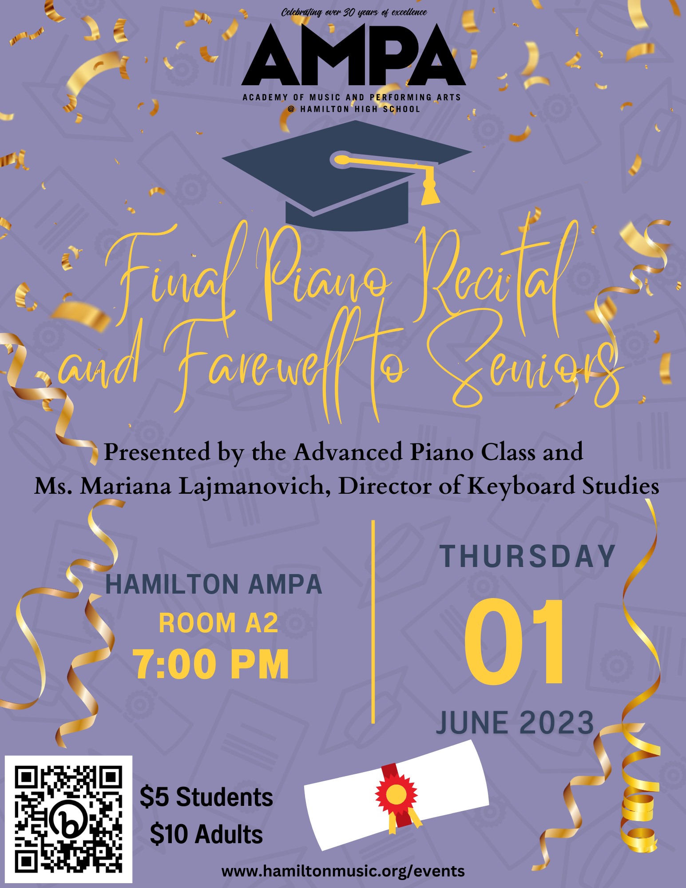

Nocturne in C Minor, Op. Post.
by Frédéric Chopin (1810-1849)
Zumir Guiden

Sonatina in C, Op. 55, No. 3
1st movement
by Friedrich Kuhlau (1786-1832)
Lukah Tumpa

Valse for one piano, six hands
by Sergei Rachmaninoff (1873-1943)
Eva Browning
Cody Holmes
Thomas Vandeman

Etude Allegro
by Yoshinao Nakada (1923-2000)
Emily McNeil

Prelude in C Minor
from The Well-Tempered Clavier, Book 1
by Johann Sebastian Bach (1685-1750)
Noah Farag

Sonata for one piano, four hands
by Francis Poulenc (1899-1963)
- Prelude
- Rustique
- Final
Hayley Ríos
Kimberly Ríos

Clair de lune
by Claude Debussy (1862-1918)
Daniel Torres

The Show Must Go On
by Georgi Slavchev (b. 1974)
Sapa Thai

Street Tango
by Astor Piazzolla (1921-1992)
Ava Elliott

Etude Op. 25 No. 1 “Aeolian Harp”
by Frédéric Chopin
Alexander Benjamin

Cinema Paradiso Themes
by Ennio Morricone (1928-2020)
arr. by Andrew Doerr
Andrew Doerr, piano
Isabel Mora, bass
Max Rubin, drums

