**Hamilton High School Complex Administrative Staff**

Jennifer Baxter, Principal

Dan Blank, Assistant Principal

April Monroe, Assistant Principal

Juan Pérez, Assistant Principal

Stephanie Lartelier, Assistant Principal

**Hamilton High School AMPA Faculty**

Susan Freitag, Director

Gail Chorna, Theater Management

Latrece Douglas, Dance

Michelle Espinosa, Choir

Monica Gelber, Musical Theater Dance

Lukas Kanter, Musical Theater

Mariana Lajmanovich, Keyboard Studies

Stephen McDonough, Guitar, Strings

Brian McGaffey, Winds, Mariachi

Alison Miller, Drama

Eric Thomas, Technical Theater

Larenz Tolson, Music Technology

Phillip Topping, Jazz Studies

Seth Townsend, Film Production

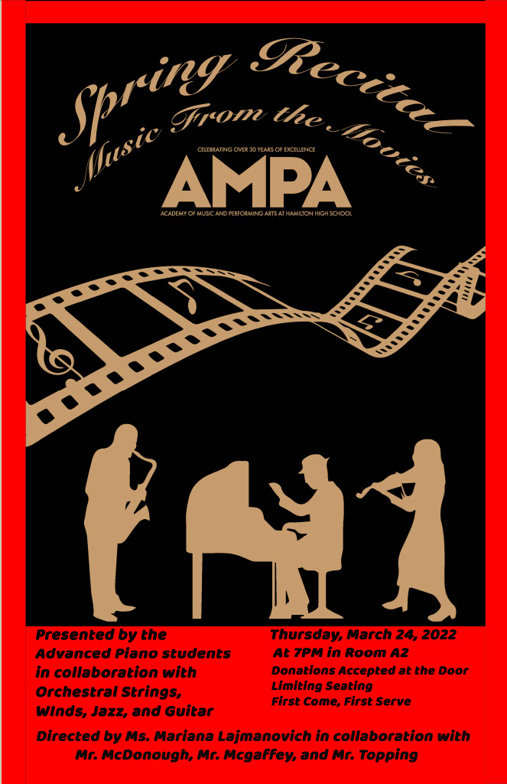

Part 1

*Viktor’s Tale,* from The Terminal

by John Williams

**Brenda Sánchez, clarinet**

**McKenzie Rundquist, piano**

*Cinema Paradiso*

by Ennio Morricone

**Hayley Ríos**

*Interstellar*

by Hans Zimmer, Alex Gibson, Ryan Rubin, arr. Patrik Pietschmann

**Alex Luna, Jr.**

*Bibo No Aozora*, from Babel

by Ryuichi Skamoto

**Rhiana Rand**

*Remember Me,* from Coco

by Kristen Anderson-López and Robert López

arr. David MacDonald

**Kimberly Ríos**

*He’s a Pirate*, from Pirates of the Caribbean

by Hans Zimmer, Klaus Badelt, Geoffrey Zanelli, arr. Reflet des Nuages

**Natalie Richards, violin**

**Emily McNeil, piano**

*Vogel im Kafig,* from Attack on Titan

by Hiroyuki Sawano, arr. PianoDeuss

**Jules Wetherwax**

*Yumeji’s Theme,* from In the Mood for Love

by Shigeru Umebayashi

**Andrew De la Peña, violin**

**Ava Elliott, piano**

*Cantina Band*, from Star Wars

by John Williams, arr. Stephen McDonough

**Advanced Guitar Ensemble:**

**Sebastian Block, Johnathan Casinto, Bryan Fernández Doroteo, Christian Gaspar, Ryan Guzmán, Celeste Hernández, Giacomo Piubeni, Nicholas Ramírez, Angel Santiago Ruiz, Josh Sazo, Riley Schmedeman, José Segura, Ellyhssa Sulca**

Intermission

Part 2

*Fletcher’s Song,* from Whiplash

by Justin Hurwitz, transcribed John Kean

**Elliot Selph, bass**

**Micah Heard, drums**

**Toussaint Pierre-Vargas, piano**

*The Avengers*

by Alan Silvestri, arr. César Bortolucci

**Andrew De la Peña, violin**

**Nathan Ortiz, cello**

**Jules Wetherwax, piano**

*Moon River*, from Breakfast at Tiffany’s

by Henry Mancini, arr. Kerin Bailey

**Noah Farag**

*Walking the Dog,* from Shall We Dance

by George Gershwin

**McKenzie Rundquist**

*Princess Mononoke*

by Joe Hisaishi, arr. Erika Shibuya

**Haruka Takashima**

*Gabriel’s Oboe,* from The Mission

by Ennio Morricone, arr. Hal Leonard

**Angel Kuk, trumpet**

**Jessica López Cruz, piano**

*Merry-Go-Round of Life*, from Howl’s Moving Castle

by Joe Hisaishi

**Lillian Weichelt, violin**

**Quincy Collinsworth, piano**

*La-La Land Suite*

by Justin Hurwitz, arr. Jacob Koller

**Sapa Thai**