Hamilton High School Complex Administrative Staff

Jennifer Baxter, Principal
Wesley Ace, Margarita Arias, Dan Blank, Stephanie Lartelier, April Monroe; Assistant Principals

Hamilton High School AMPA Faculty

Michelle Espinosa, Director
Justin Braun, Choir
Gail Chorna, Theater Management
Latrece Douglas, Dance
Jennifer Gordon, Musical Theater
Mariana Lajmanovich, Keyboard Studies
Stephen McDonough, Guitar & Strings
Brian McGaffey, Winds & Mariachi
Alison Miller, Drama
Maritza Olmos, Folklórico
Eric Thomas, Technical Theater
Larenz Tolson, Music Technology
Phillip Topping, Jazz Studies
Seth Townsend, Film Production

For more information on the AMPA Piano Department,
please visit www.hamiltonpiano.org

You may donate to AMPA Piano Department

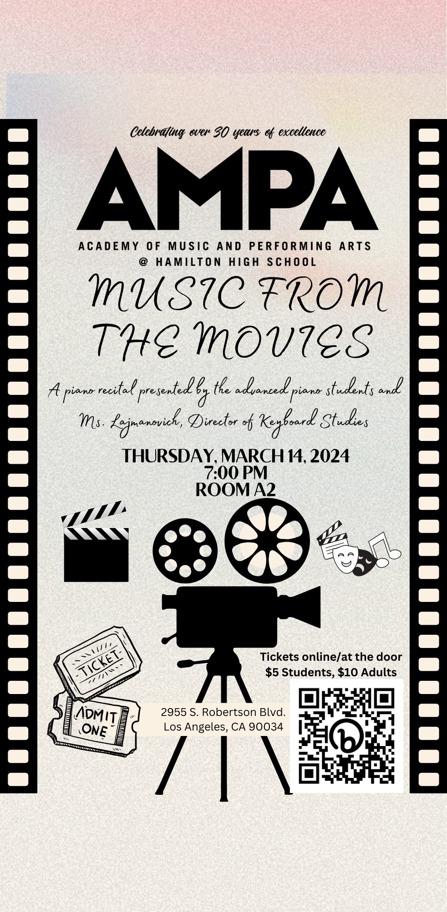

Mission Impossible
by Lalo Schifrin, arr. Joel Goodman
Michael Miranda
Andre Vargas

Can You Feel the Love Tonight? from The Lion King
by Elton John, arr. Sharon Aaronson
Lukah Tumpa

The James Bond Theme
by Monty Norman
Frida Anderson
Moa Ball

Walking the Dog from Shall We Dance
by George Gershwin
Nina Schwartz

God Help the Outcasts
from The Hunchback of Notre Dame
by Alen Menken, arr. Phillip Keveren
Cody Holmes

Cantina Band from Star Wars
by John Williams, arr. Phillip Keveren
Isaac García
Max Olsen

Program

Mia and Sebastian’s Theme from La-La-Land
by Justin Hurwitz
Emily McNeil

The Simpsons
by Danny Elfman, arr. Tim Cutting
Cody Homes, Alex Ramírez

Medley from Marie Antoinette
by Dustin O’Halloran
Eva Browning

Riko in the Aquarium from Jujutsu Kaisen
by Yoshimasa Terui
Tommy Vandeman

Nocturne in C Sharp Minor, Op. Posthumous
from The Pianist
by Frédéric Chopin
Alexander Benjamin

As Time Goes By from Casablanca
by Herman Hupfeld, arr. Noah Farag
Noah Farag, piano
Isabel Mora, bass
Ryder Magtaas, drums

