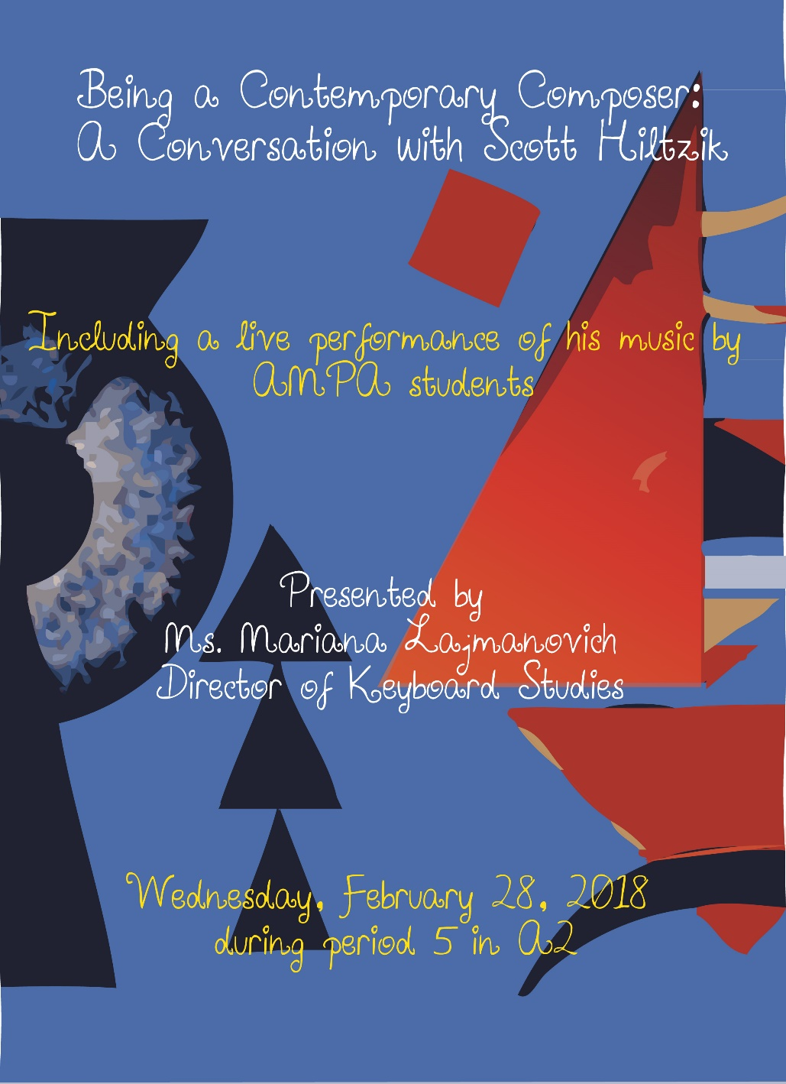

**Performers**

**Von Buena** Denouement:

**(Piano)** Tempestoso

**Madeline Lyons** Summer Lullaby

**(Piano)**

**Sayaka Alessandroni (Piano)**

**Annie Ragni (Cello)** Kianna Taylor

**Quynh Nguyen** December Waiting

**(Piano)**

**Daphne Moss (Flute)**

**Mark Chang (Piano)** A Touch of Tango

**Dalton Hayse (Piano)** Rag Doll