Hamilton High School Complex Administrative Staff
Jennifer Baxter, Principal
Wesley Ace, Dan Blank,
Stephanie Lartelier, April Monroe,
Juan Pérez, Assistant Principals

Hamilton High School AMPA Faculty

Michelle Espinosa, Magnet Coordinator
Gail Chorna, Theater Management
Latrece Douglas, Dance
Monica Gelber, Musical Theater Dance
Lukas Kanter, Musical Theater
Mariana Lajmanovich, Keyboard Studies
Stephen McDonough, Guitar, Strings
Brian McGaffey, Winds, Mariachi
Alison Miller, Drama
Eric Thomas, Technical Theater
Larenz Tolson, Music Technology
Phillip Topping, Jazz Studies
Seth Townsend, Film Production

*Piano Majors, Class of 2022*

Faith Ardoin Quincy Collinsworth
Jessica López Cruz Alex Luna, Jr.
Toussaint Pierre-Vargas Dream Pogue
Rhiana Rand Brianna Rivera
Angel Rodríguez García Haruka Takashima
Jules Wetherwax

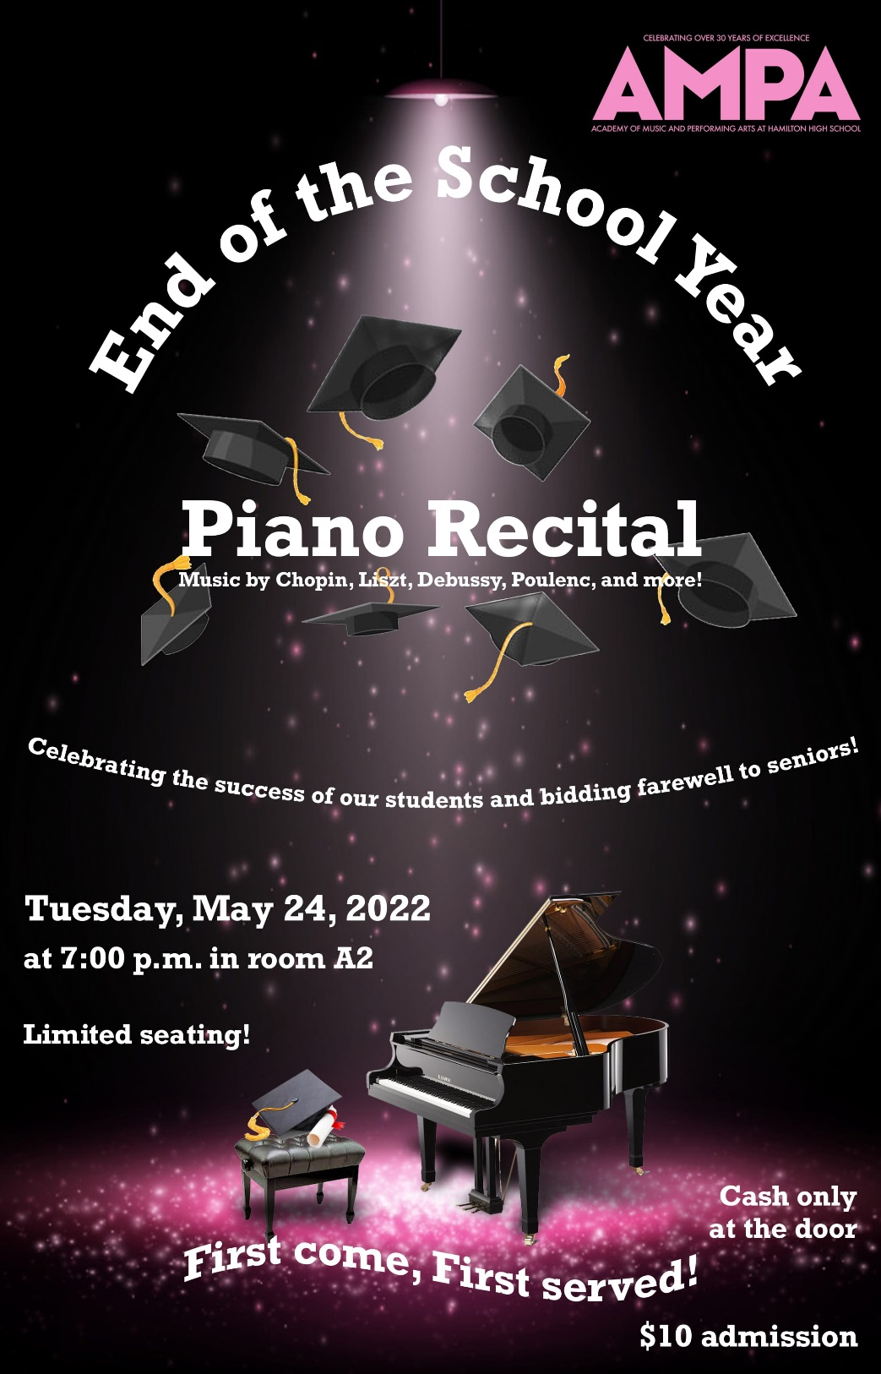

Part II

Prelude, Op. 28 No. 4 in E Minor
by Frédéric Chopin
(1810-1849)
Angel Rodríguez García*

Cantos de España, Op. 232 No. 2: Orientale
by Isaac Albéniz
(1860-1909)
Jules Wetherwax*

Notturno, Op. 54 No. 4
by Edvard Grieg
(1843-1907)
Rhiana Rand*

Nocturne in C Sharp Minor, Op. Posthumous
by Frédéric Chopin
Alex Luna, Jr.*

Nocturne, Op. 55 No. 1 in F Minor
by Frédéric Chopin
Jessica López Cruz*

Etude, Op. 25 No. 5 in E Minor
by Frédéric Chopin
Toussaint Pierre-Vargas*

Nocturne, Op. 48 No. 1 in C Minor
by Frédéric Chopin
Haruka Takashima*

Liebestraum
by Franz Liszt
(1811-1886)
Quincy Collinsworth*

*denotes class of 2022 Piano Major

Thank you, parents and friends, for your continued support!

Part I

Fantasie in G Minor, TWV 33:8
by Georg Philipp Telemann
(1861-1767)
Sapa Thai

Golliwog’s Cakewalk
by Claude Debussy
(1862-1918)
Noah Farag

Sonata, Op. 79 in G Major, 1st movement
by Ludwig van Beethoven
(1770-1827)
Emily McNeil

Reverie
by Claude Debussy
McKenzie Rundquist

Trois mouvements perpétuels
No. 1 Assez modéré
No. 2 Tres modéré
by Francis Poulenc
(1899-1963)
Andrew Doerr

Flora’s Game
by Astor Piazzolla
(1921-1992)
Ava Elliott

Prelude and Fugue No. 16 in G Minor (WTC 1)
by Johann Sebastian Bach
(1685-1750)
Alexander Benjamin

Intermission

Nocturne in C Sharp Minor, Opus Posthumous
Christian Gaspar, Ryan Guzmán, Celeste Hernández, Giacomo Piubeni, Nicholas Ramírez, Angel Santiago Ruiz, Josh Sazo, Riley Schmedeman, José Segura, Ellyhssa Sulca

Intermission

