Hamilton High School Complex Administrative Staff
Jennifer Baxter, Principal
Dan Blank, Assistant Principal
April Monroe, Assistant Principal
Juan Pérez, Assistant Principal
Stephanie Lartelier, Assistant Principal

Hamilton High School AMPA Faculty

Michelle Espinosa, Director
Justin Braun, Choir
Gail Chorna, Theater Management
Latrece Douglas, Dance
Lukas Kanter, Musical Theater
Mariana Lajmanovich, Keyboard Studies
Stephen McDonough, Guitar, Strings
Brian McGaffey, Winds, Mariachi
Alison Miller, Drama
Martiza Olmos, Folklórico
Eric Thomas, Technical Theater
Phillip Topping, Jazz Studies
Seth Townsend, Film Production

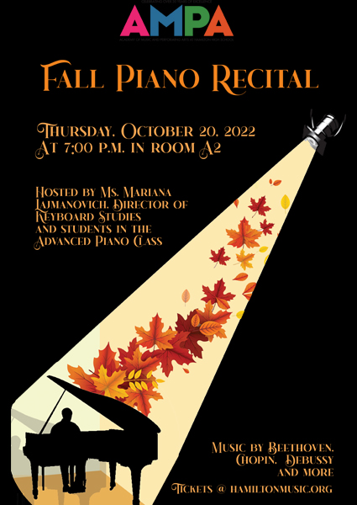

Chanson Triste
by Vasili Sergeyevich Kalinnikov
(1866-1901)
Thomas Vandeman

Solfeggietto
by Carl Philipp Emanuel Bach
(1714-1788)
Lukah Tumpa

Moonlit Meadows
by Sergei Prokofiev
(1891-1953)
Zumir Guiden

Toccata Brillante
by Dennis Alexander
(b. 1947)
Cody Holmes

Sonata No. 18 in A Major
by Domenico Cimarosa
(1749-1801)
Emily McNeil

The Girl with the Flaxen Hair
by Claude Debussy
(1862-1918)
Eva Browning

Sonata Op. 10 No. 1 in C Minor
1st movement: Allegro molto e con brio
by Ludwig van Beethoven
(1770-1827)
Noah Farag

Prélude
by Maurice Ravel
(1875-1937)
Ava Elliott

Waltz in C Sharp Minor
by Frédéric Chopin
(1810-1849)
Daniel Torres

Sonata Op. 6 in D Major for 1 piano, 4 hands
1st movement: Allegro molto
by Ludwig van Beethoven
Kimberly Ríos, primo
Hayley Ríos, secondo

Nocturne in D Flat Major
“Un reve”
by Erich Christian von Fricken
(b. 1991)
Andrew Doerr

Prelude No. 8 in E Flat Minor
from The Well-Tempered Clavier, Book 1
by Johann Sebastian Bach
(1685-1750)
Alexander Benjamin

Sonata Op. 31, No. 2 in D Minor “The Tempest”
1st movement: Largo-Allegro
by Ludwig van Beethoven
Sapa Thai

