Hamilton High School Complex Administrative Staff

Jennifer Baxter, Principal
Wesley Ace, Margarita Arias, Dan Blank, Stephanie Lartelier, April Monroe, Juan Pérez, Assistant Principals

Hamilton High School AMPA Faculty

Michelle Espinosa, Director
Justin Braun, Choir
Gail Chorna, Theater Management
Latrece Douglas, Dance
Jennifer Gordon, Musical Theater
Mariana Lajmanovich, Keyboard Studies
Stephen McDonough, Guitar & Strings
Brian McGaffey, Winds & Mariachi
Alison Miller, Drama
Maritza Olmos, Folklórico
Eric Thomas, Technical Theater
Larenz Tolson, Music Technology
Phillip Topping, Jazz Studies
Seth Townsend, Film Production

For more information of the AMPA Piano Department,
please visit www.hamiltonpiano.org

You may donate to AMPA Piano Department here:

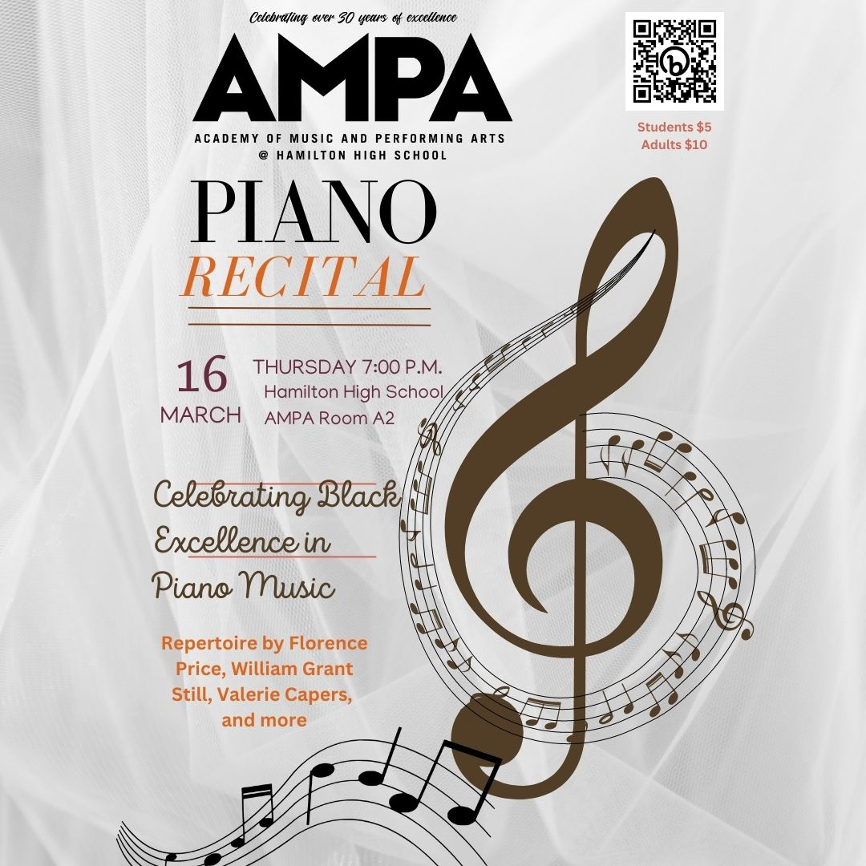

Presented by Ms. Mariana Lajmanovich
Director of Keyboard Studies
AMPA @ Hamilton High School

A Taste of Bass
by Valerie Capers (b. 1935)
Lukah Tumpa

A Summer Day
by Lena McLin (b. 1928)
Eva Browning

Blues from Lenox Avenue
by William Grant Still (1895-1978)
Cody Holmes

Silk Hat and Walking Cane
by Florence Beatrice Price (1887-1953)
Kimberly Ríos

From the Southland
by Harry Thacker Burleigh (1866-1949)
with poems by Louise Alston Burleigh
III. In de Col’ Moonlight
Daniel Torres
IV. A Jubilee
Emily McNeil
Poetry Recitation by Jane Brinkley

Cell Phone Blues
by Ed Bland (1926-2013)
Eva Browning

Waltz for Miles
by Valerie Capers
Zumir Guiden

A Deserted Plantation
II: Young Missy
by William Grant Still
Thomas Vandeman

Variations on an Egyptian Folk Song
by Gamal Abdel Rahim (1924-1988)
Hayley Ríos

Billie’s Song
by Valerie Capers
Noah Farag

Sometimes I Feel Like a Motherless Child
arr. by Samuel Coleridge Taylor (1875-1912)
Alexander Benjamin

Misty
by Erroll Garner (1921-1977)
Andrew Doerr, piano
Isabel Mora, bass
Max Rubin, drums

MC: Siyana Da’Briel

