**Hamilton High School Complex Administrative Staff**

Brenda Pensamiento, Principal

Dan Blank, Assistant Principal

Sergio Cota, Assistant Principal

Sean Gosselin, Assistant Principal

Stephanie Lartelier, Assistant Principal

Fran Rose, Assistant Principal

**Hamilton High School Academy of Music Performing Arts Faculty**

Marlene Zuccaro, Director

Bob Bruning

Zachary Burch

Gail Chorna

Latrece Douglas

Jim Foschia

Mariana Lajmanovich

Stephen McDonough

Alison Miller

Greg Robinson

Sam Toffler

Wendy Walsh

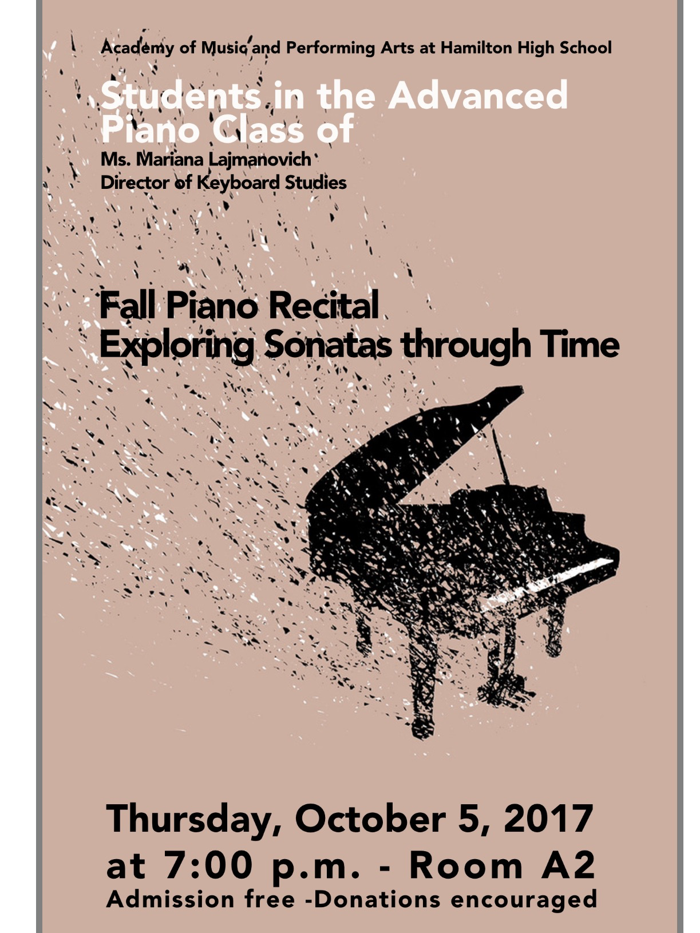

*Two Sonatas* by Wolfgang Amadeus Mozart (1756-1791)

*C Major K. 545:* II. Andante

**Sayaka Alessandroni**

*F Major K.332:* I. Allegro

**Alta Magruder**

Ludwig van Beethoven

*Sonata Op. 79 in G Major*

1. Presto alla tedesca

**Alex de la Torre-McGee**

*Sonata Op. 14 No. 1 in E Major*

1. Allegro

**Sahndra Magee**

*Sonata Op. 27 No. 2 “Moonlight”*

III.Presto agitato

**Quynh Nguyen**

*Sonata Op. 10 No. 1 in C Minor*

III.Finale Prestissimo

**Mark Chang**

*Sonata Op. 13 “Pathétique”*

1. Grave-Allegro di molto e con brio

**Madeline Lyons**

*Sonata Op. 53 “Waldstein”*

1. Allegro con brio

**Connie Lim**

*Sonata Op. 58 No. 3 in B Minor*

by Frédéric Chopin (1810-1849)

IV.Finale –Presto non tanto

**Von Buena**

*Sonata No. 1 Op. 22*

by Alberto Ginastera (1916-1983)

1. Allegro marcato

**Dalton Hayse**

**Program**

*Sonata Op. 49. No. 1 in G Minor*

by Ludwig van Beethoven (1770-1827)

1. Andante

**Bennett Wyler**

*Sonatina Op. 13, No. 1in C Major*

by Dimitri Kabalevsky (1904-1987)

1. Allegro assai e lusingando

**Veronica Zellers**

*Sonata L. 79 in G Major*

by Domenico Scarlatti (1685-1757)

**Brian Avila**

*Sonata in C Major*

by George Frederic Handel (1685-1759)

**Livia Long-Baltaxe**

*Two Sonatinas Op. 36* by Muzio Clementi (1752-1832)

*No. 4 in F Major* : I. Con spirito

**Polette Garrido**

*No. 6 in D Major:* I. Allegro con spirito**Elder Gindroz**

*Two Sonatas* by Franz Joseph Haydn

(1732-1809)

*Hob. XVI No. 1 in C Major*

1. Allegro
2. Andante
3. Minuet and Trio

**Eva Hochhaus**

*Hob. XVI No. 37 in**D Major*

*I. Allegro con brio*

**America Tepeu Lopez**